**EEC 134 Final Report**

***Team Falcon 9***

Alejandro Venegas

Marco Venegas

Alexis Torres

Gerardo Abrego

Abstract: EEC 134

By Falcon 9

In the EEC 134 course the focus is on RF/microwave systems design. The main objective of the course is to teach the students about the necessary components that go into designing such systems. For example, the product of the course is a frequency modulated continuous wave (FMCW) radar system for short range applications. We begin the course by learning about the individual components that go into implementing a radar. The class introduces us to RF amplifiers, oscillators, mixers, and antennas. From the very beginning we can practice printed circuit board (PCB) design as part of the first couple of labs and from these initial stages we are able to eventually move onto the final assembly of the system. By the end of the first half of the course we have a good foundation of what makes a system like this work successfully. In the second half of the course the main objective is to improve upon the first system that we built. This can include different factors such as size, weight, cost, and performance. Once a design is proposed groups can then go ahead and begin building the improved systems. In the end a competition is held to see which group in the class built the best system by taking all the previous factors into consideration.

**Introduction:**

A FMCW radar uses a continuous wave signal for transmission. The frequency changes with respect to time in a specific pattern such as a saw tooth wave or a triangle wave. A triangle wave example is shown below.

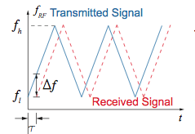

These patterns are achieved by ramping the control voltage of the VCO in the transmitting side up and down. To continuously change the frequency of the VCO, a microcontroller was used to provide a constant ramping signal (like the one shown above). An overall system level design of the radar is shown below.

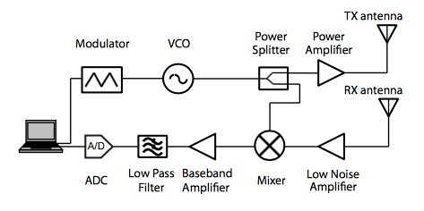

Again, the modulator is the system is a teensy 3.1. Depending on the VCO, a certain amount of power (ranging from 2 to 7 dBm) is constantly being outputted, which is independent of frequency. Note the amount of power being outputted by the VCO is dependent on the manufacturer, so check the data sheets. The splitter even splits the VCO output in half and sends it through the transmitting and Mixer(receiving). Note this signal will be used as the LO on the mixer.

Once the signal has left the transmitting antenna the frequency no longer changes, so when the signal is received the frequencies between the transmitting signal and the received differ. This is due to the fact the signal is traveling through a somewhat lossy medium. This is intended because this difference is can then be retrieved by a frequency mixer. If the receiving and LO signal had the same frequency, no signal would be transferred to the baseband, thus nothing is being recovered. More importantly, the difference corresponds to delay of the radar signal that is brought about from travelling to and from the target. From here the distance to the target can be computed using the difference in frequencies.

A FMCW radar is desirable for short range applications because it uses a lot less power than a regular CW radar and it can be made to be very small in size. The overall system works by first modulating a voltage that is fed into the VCO, which then creates the RF signal that will be transmitted. This signal is then split and sent to the mixer as well. The transmitting signal propagates to a power amplifier to boost the signal right before being sent out of the transmitting antenna. When the reflected signal reaches the receiving antenna, it is then passed to a low noise amplifier because the returned signal is very weak and needs to be amplified for processing. The mixer then retrieves the difference between the transmitting frequency and the received frequency. This mixed down signal is then moved to a baseband amplifier and low pass filter in order to processed in a computer. The received signal is saved using an audio recording software fed by an audio cable connected to the radar system. From here the recorded audio file is processed and a plot is created that displays the distance of the object with respect to time.

**Design and Implementation:** For our radar design we improved upon our quarter 1 system. We kept the same overall radar system block with a few modifications, with a few key differences. Those can be seen in the figure below. Unlike our quarter 1 system we had the freedom of choosing our components. Below is the list of the components we selected. In selecting our components, we also considered how much the components cost since we had a budget of $300. Note, quarter one system has the output of the power amplifier being split between the transmitting and receiving. The reason being was that the mixer being used was a level 12, meaning the required signal is about 12dBm. This design purposely bypass this by finding other components that work at lower power levels. The transmitting side of the radar was designed to output a signal of about 25-28dBm (close to about 1W of power). One thing to note is that one power amplifier was used in order to try and avoid compression. After calculating the power being received at different distance. This radar is designed to read up to a distance of about 75m. Lastly, the antennas for the transmitting and receiving were a Yagi and Coffee Can. A Yagi was used for the transmitting side because the fact is that is much more directive than the coffee can. Meaning, this antenna provides a more concentrated signal at a specific region, relative to the coffee can. However, since the coffee can was not as directive, it was able to catch reflected signal better.

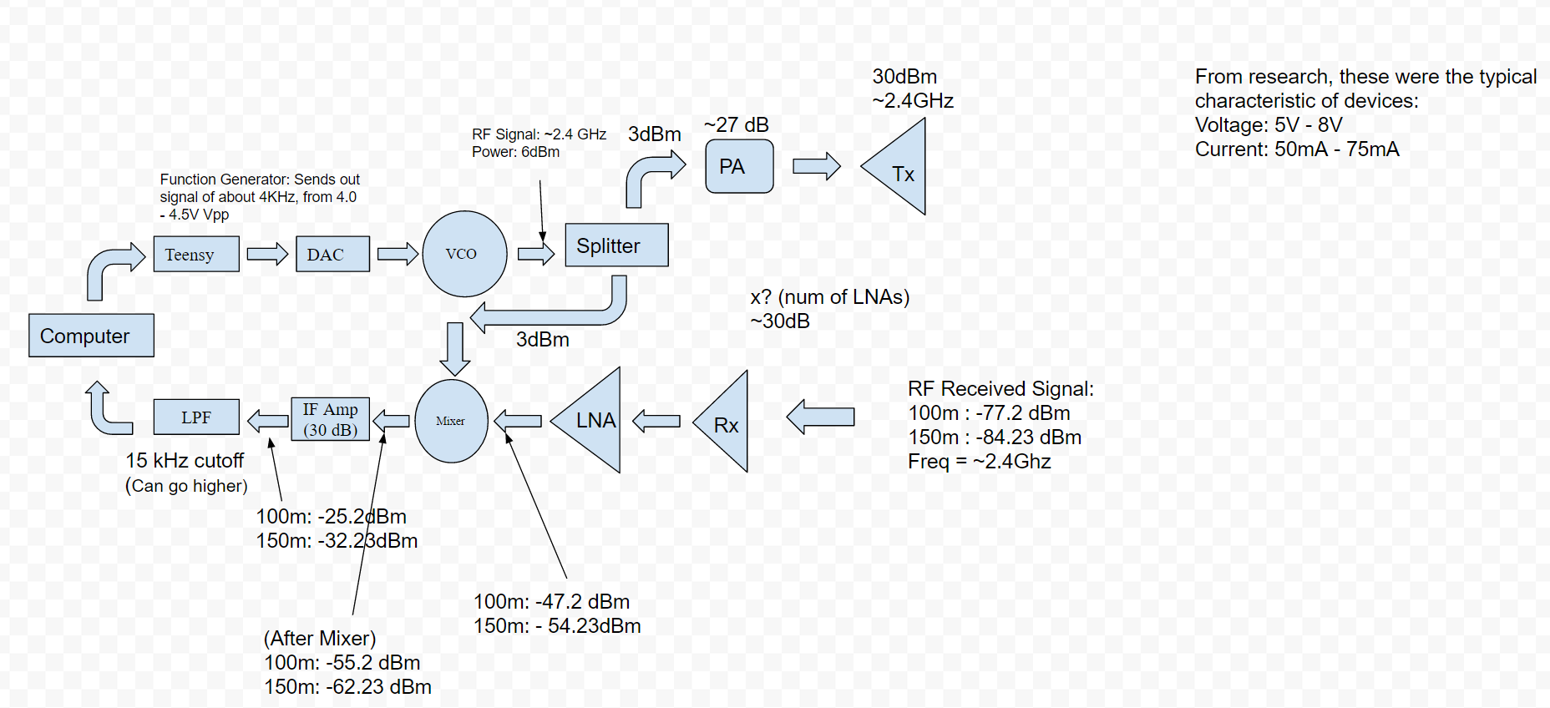

**Power Amp**

Analog Devices ADL5545

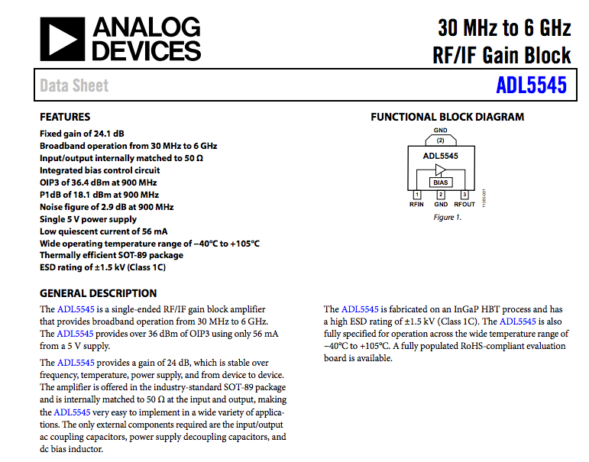

**Splitter**

Mini Circuits SP-2U2+

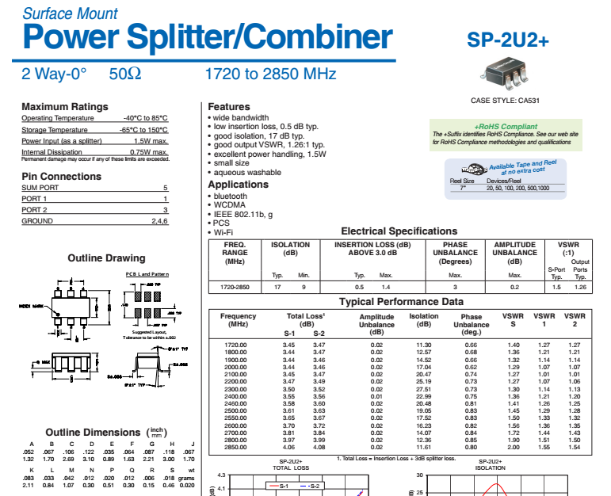

**Low Noise Amplifier** **(LNA)**

Mini Circuits PMA3-83LN+ and Mini Circuits DQ1225

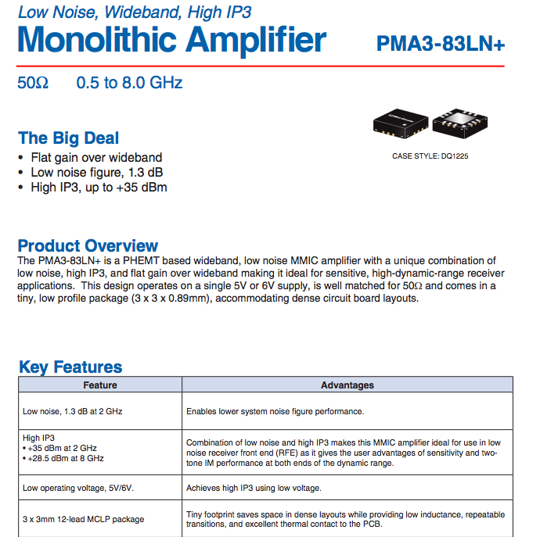

**Mixer**

Analog Devices HMC215LP4

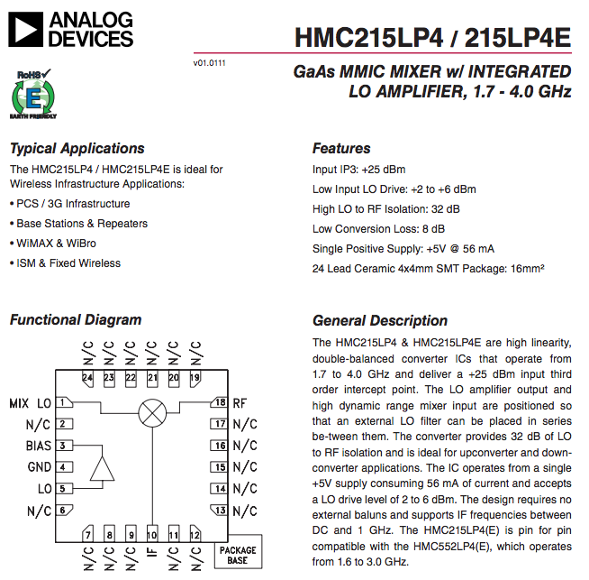

**Voltage Control Oscillator (VCO)**

Mini Circuits ROS-2490+

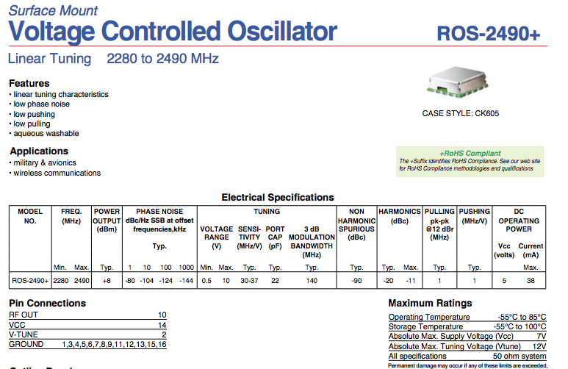

**Antenna**

2.4 GHz UHF Antenna

We ordered Yagi Antennas because we know that they have a better directivity. We used it for our transmitting side. We recorded its return loss using the TA’s system in the lab. The return loss was about -40.0 dB and centered at 2.4 GHz

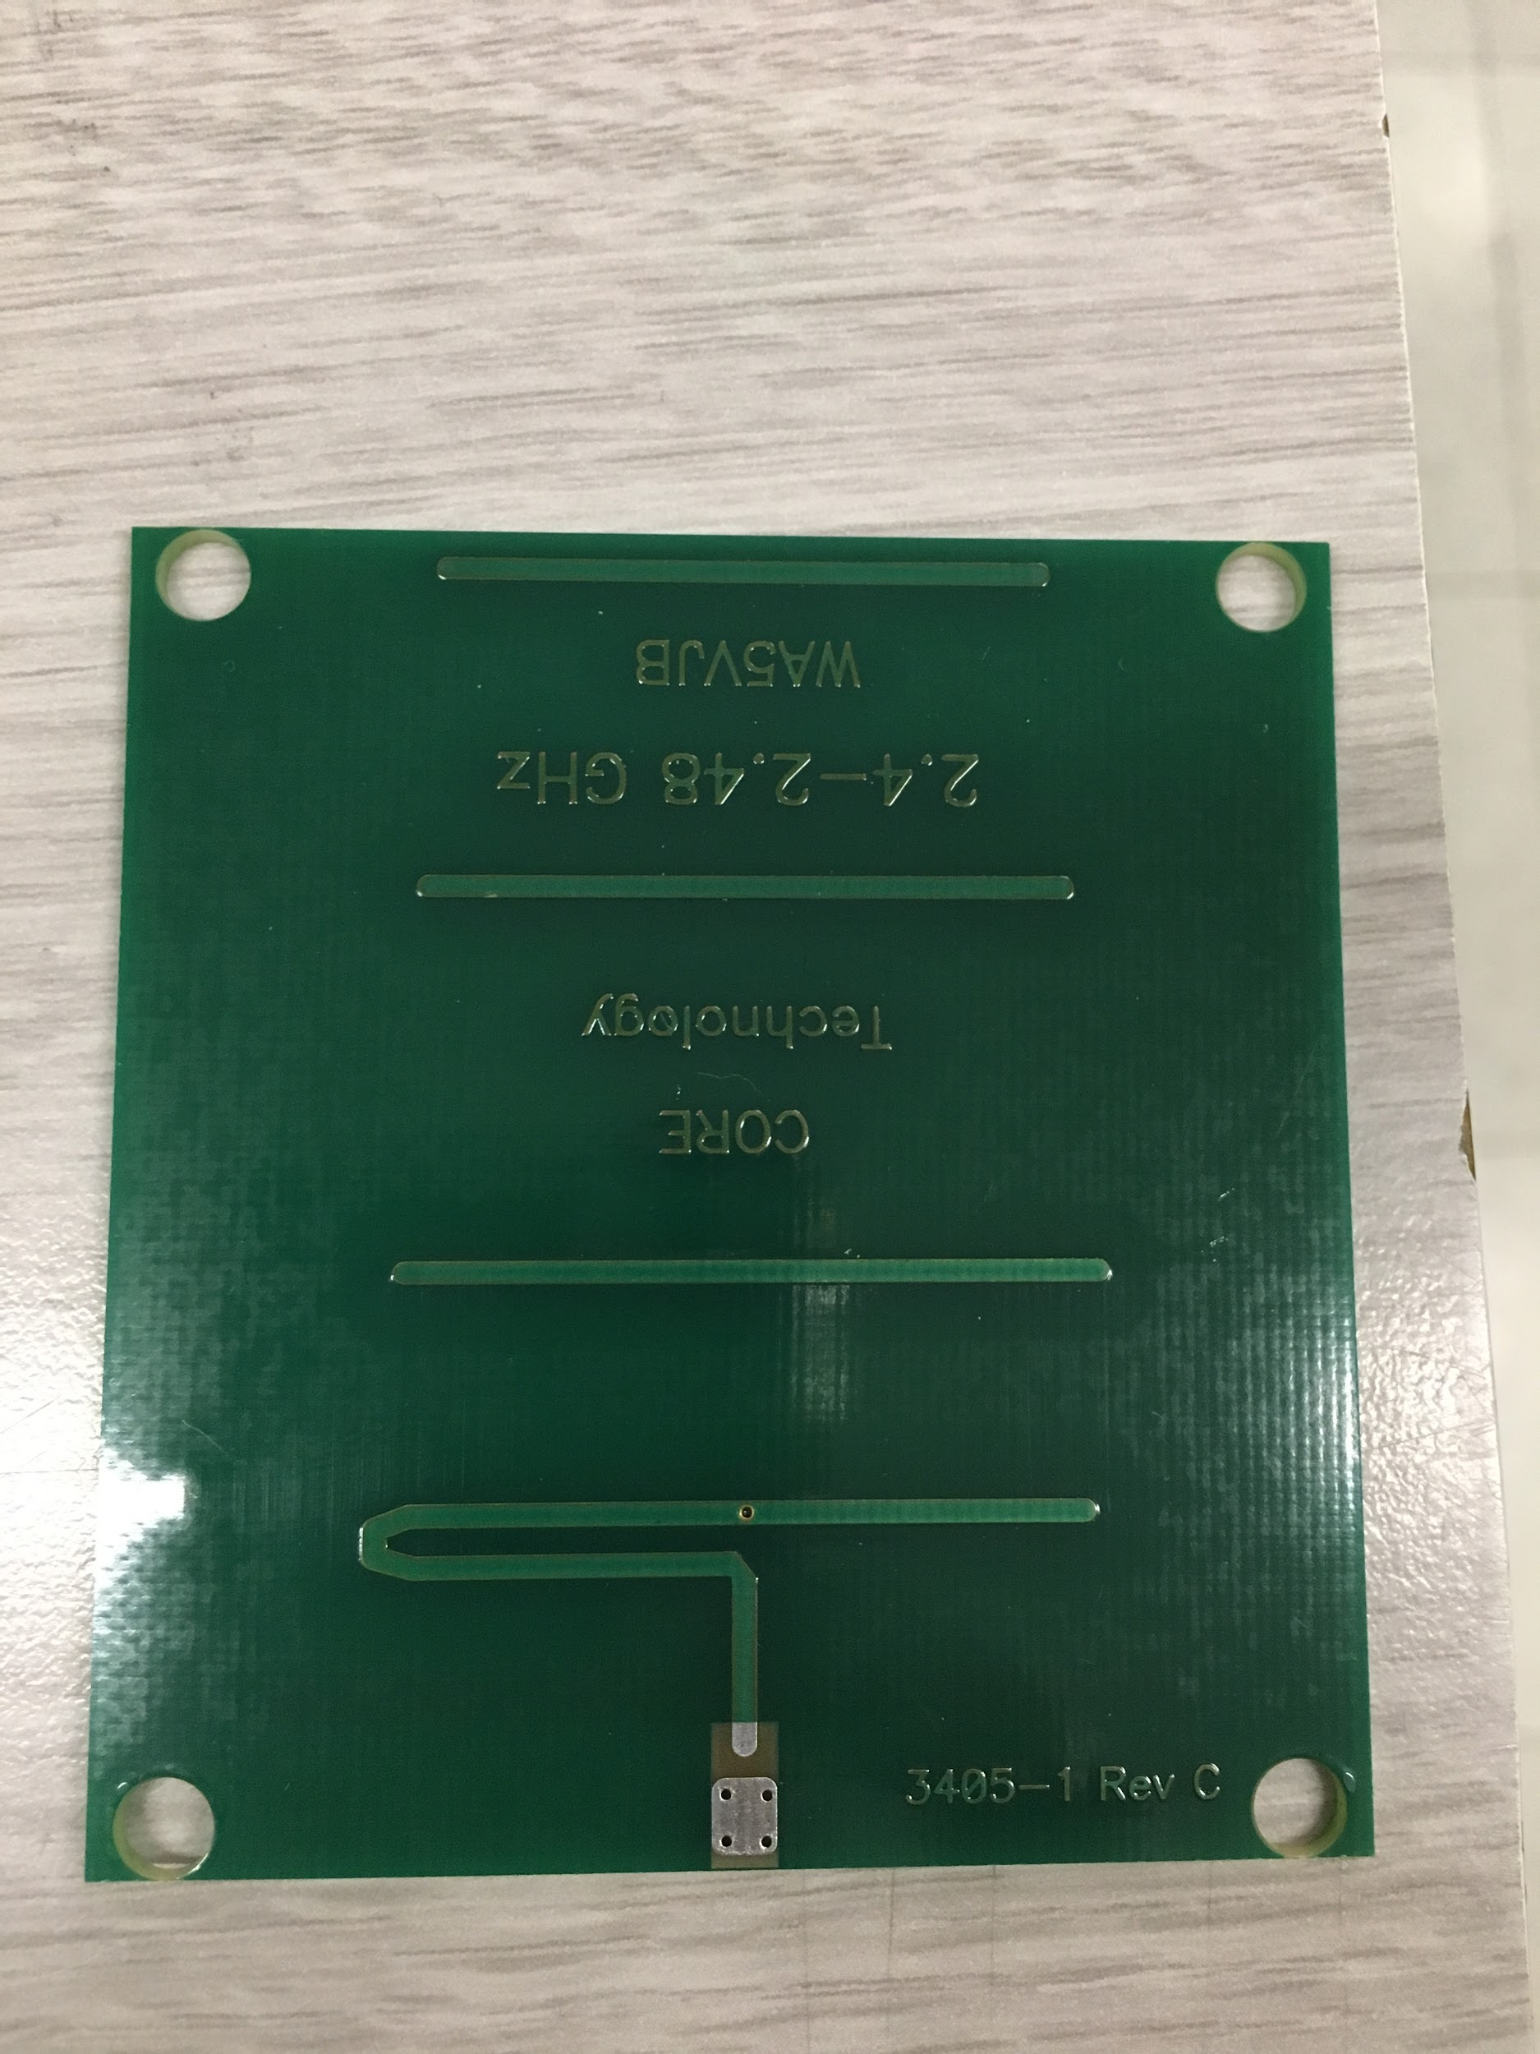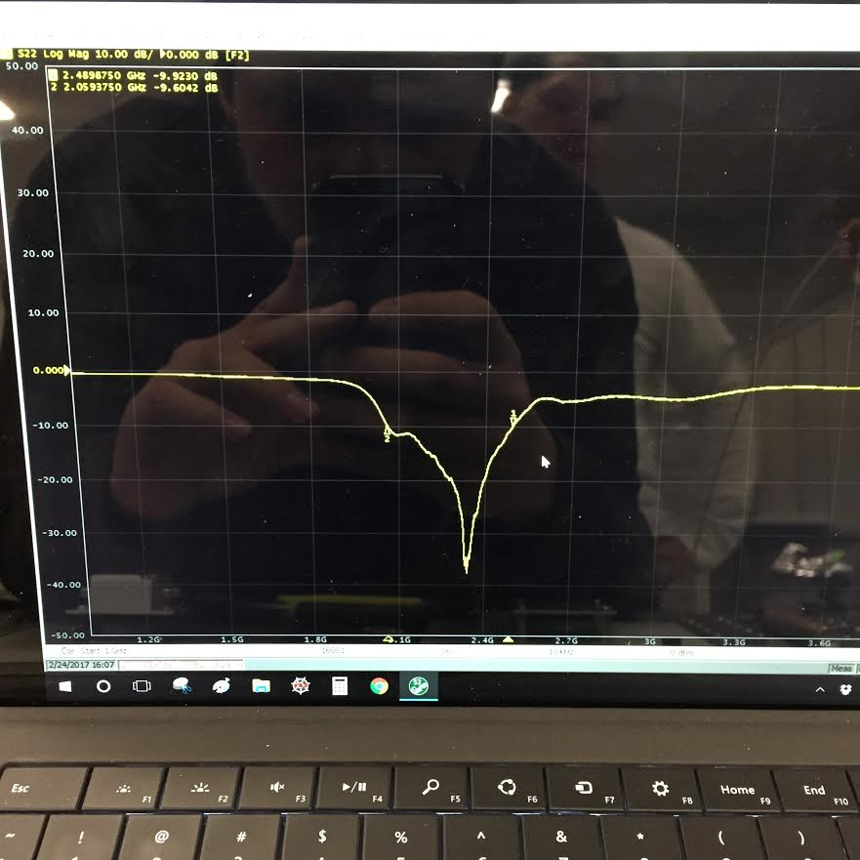

Fig 1: Yagi Antenna and Return Loss

**PCB Design:**

We had two separate PCB designs. One was our baseband board which contained the low pass filter stage, DAC, teensy and Gain stage. The other was our RF board which contained our LNA’s, power amp, mixer, splitter, VCO and SMA heads so we can connect to our transmitting and receiving antennas. We had practice in designing during the PCB runs in quarter 1 and used similar layouts for our final PCB design. The only difference was that we had to make footprints for all of our chosen figures, but with the help of the data sheets were able to design them. Below are figures of our schematic layouts for both our baseband and RF boards.

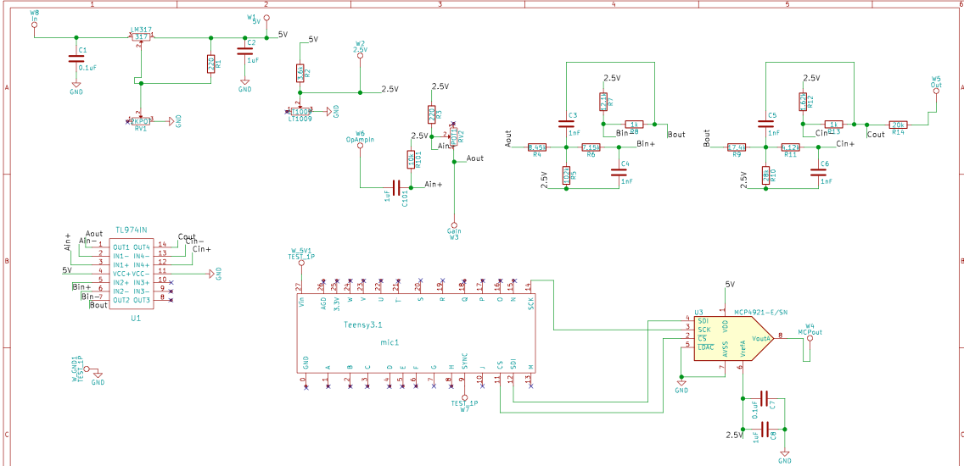

Fig 2: Baseband Board Schematic

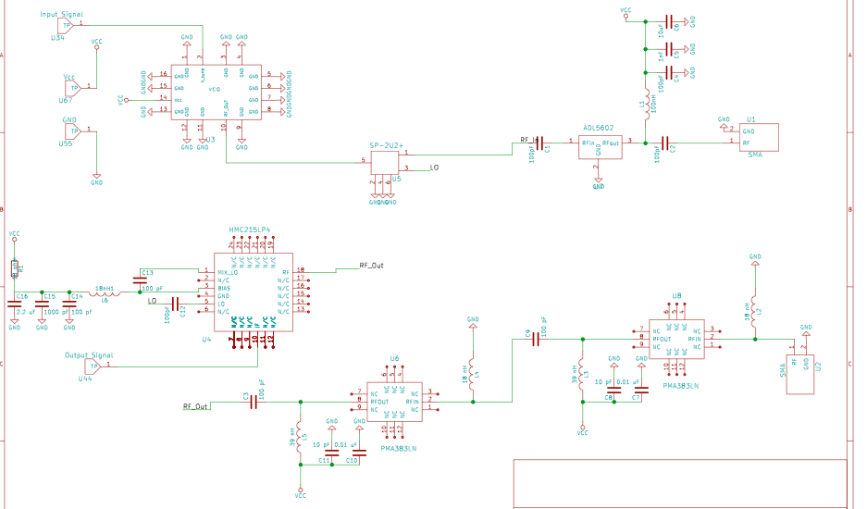

Fig 3: RF Board Schematic

Once we had our PCB schematic layout we designed the actual PCB. The baseband had many capacitors and resistors so we tried to keep them as close to their corresponding IC’s as possible. For our RF board we had less components, but it was just as challenging to have a good layout because RF traces should be kept as straight as possible. After experimenting with placement, we were able to find a place for all the components and had straight traces. We then send out our PCBs. When we received, them we began to solder the components onto the boards. We didn’t have too much trouble getting components on we used a combination of the solder gun, heat plate and hot air gun.

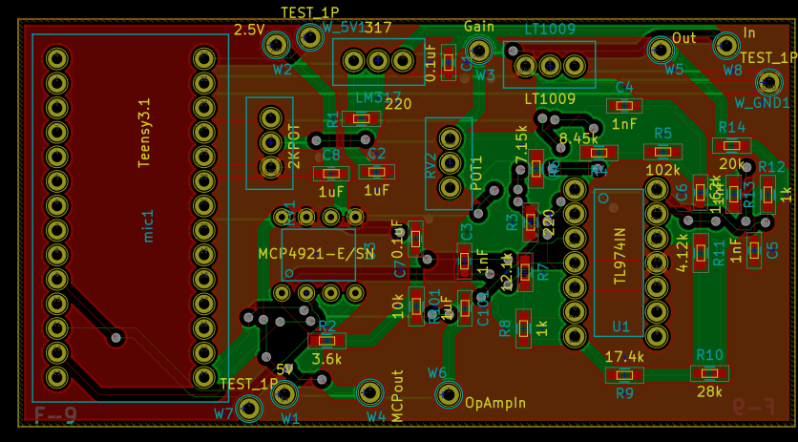

Fig 4: Baseband PCB Layout

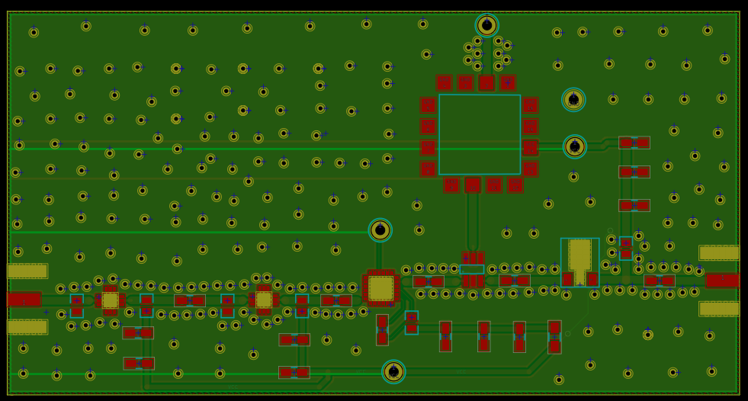

Fig 5: RF PCB layout

**Testing and Results:**

Once we had our assembled boards we began to test. We first started with our baseband board. We connected and provided power to the board, but were unable to get the results we wanted. Turns out we made a little mistake in terms of the output for the DAC. Immediately after noticing this our team turned to our backup plan. We rebuilt the baseband board on a proto board. This was still a good solution because we would still have a lighter system using a proto board instead of a breadboard like in quarter 1. After assembling the system, we had it working and were able to move forward to the RF board.

The RF board worked perfectly we tested the components separately. We first tested the VCO we used different voltage references and used the spectrum analyzer to read the output frequency.

We then tested the mixer by using the oscilloscope and function generator. We were able to get a mixed down signal from the output verifying that it worked properly.

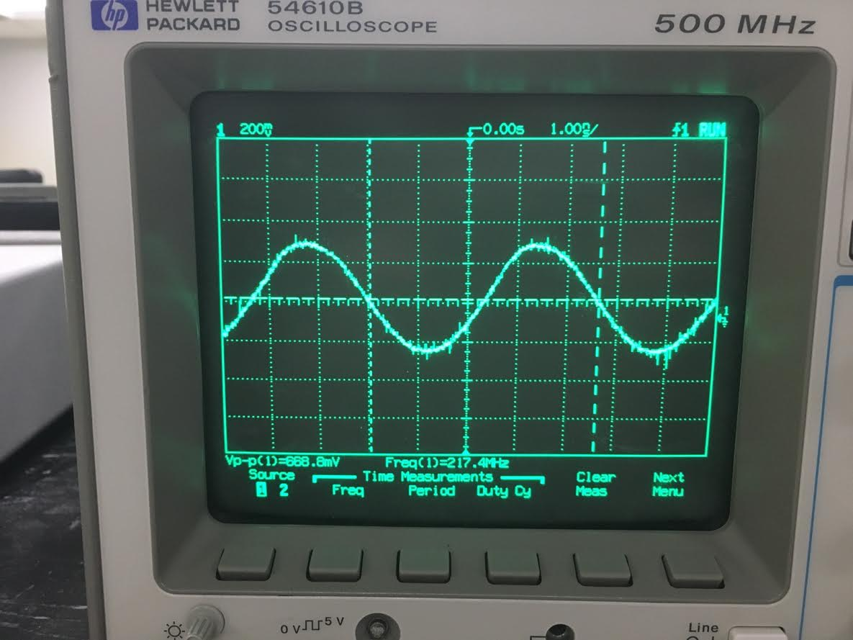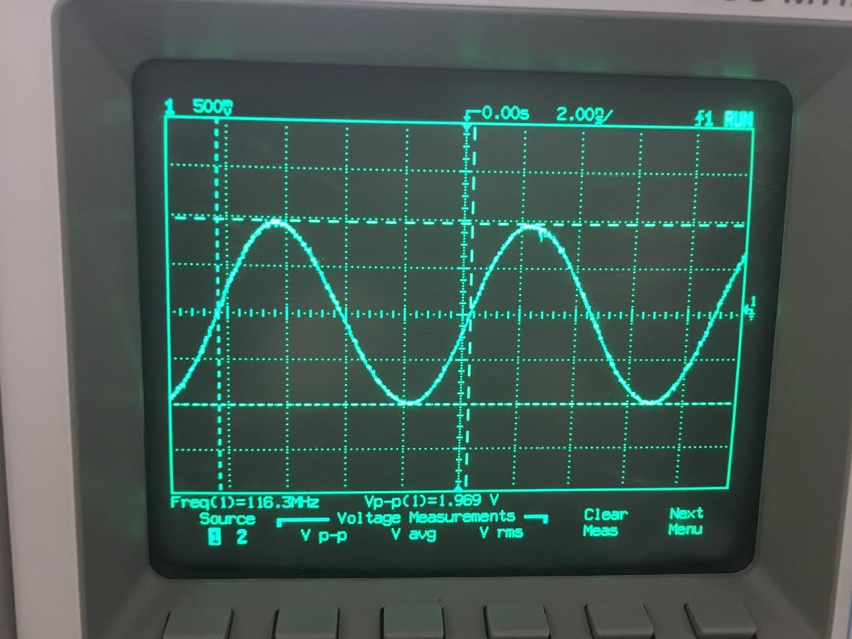

Fig 1: Mixer Output

Afterwards we tested the RF board using synthesizers and confirmed it was working properly we got a 20.7 dBm output, but we believe it was higher because the spectrum analyzer only gave us a 20 dBm reference.

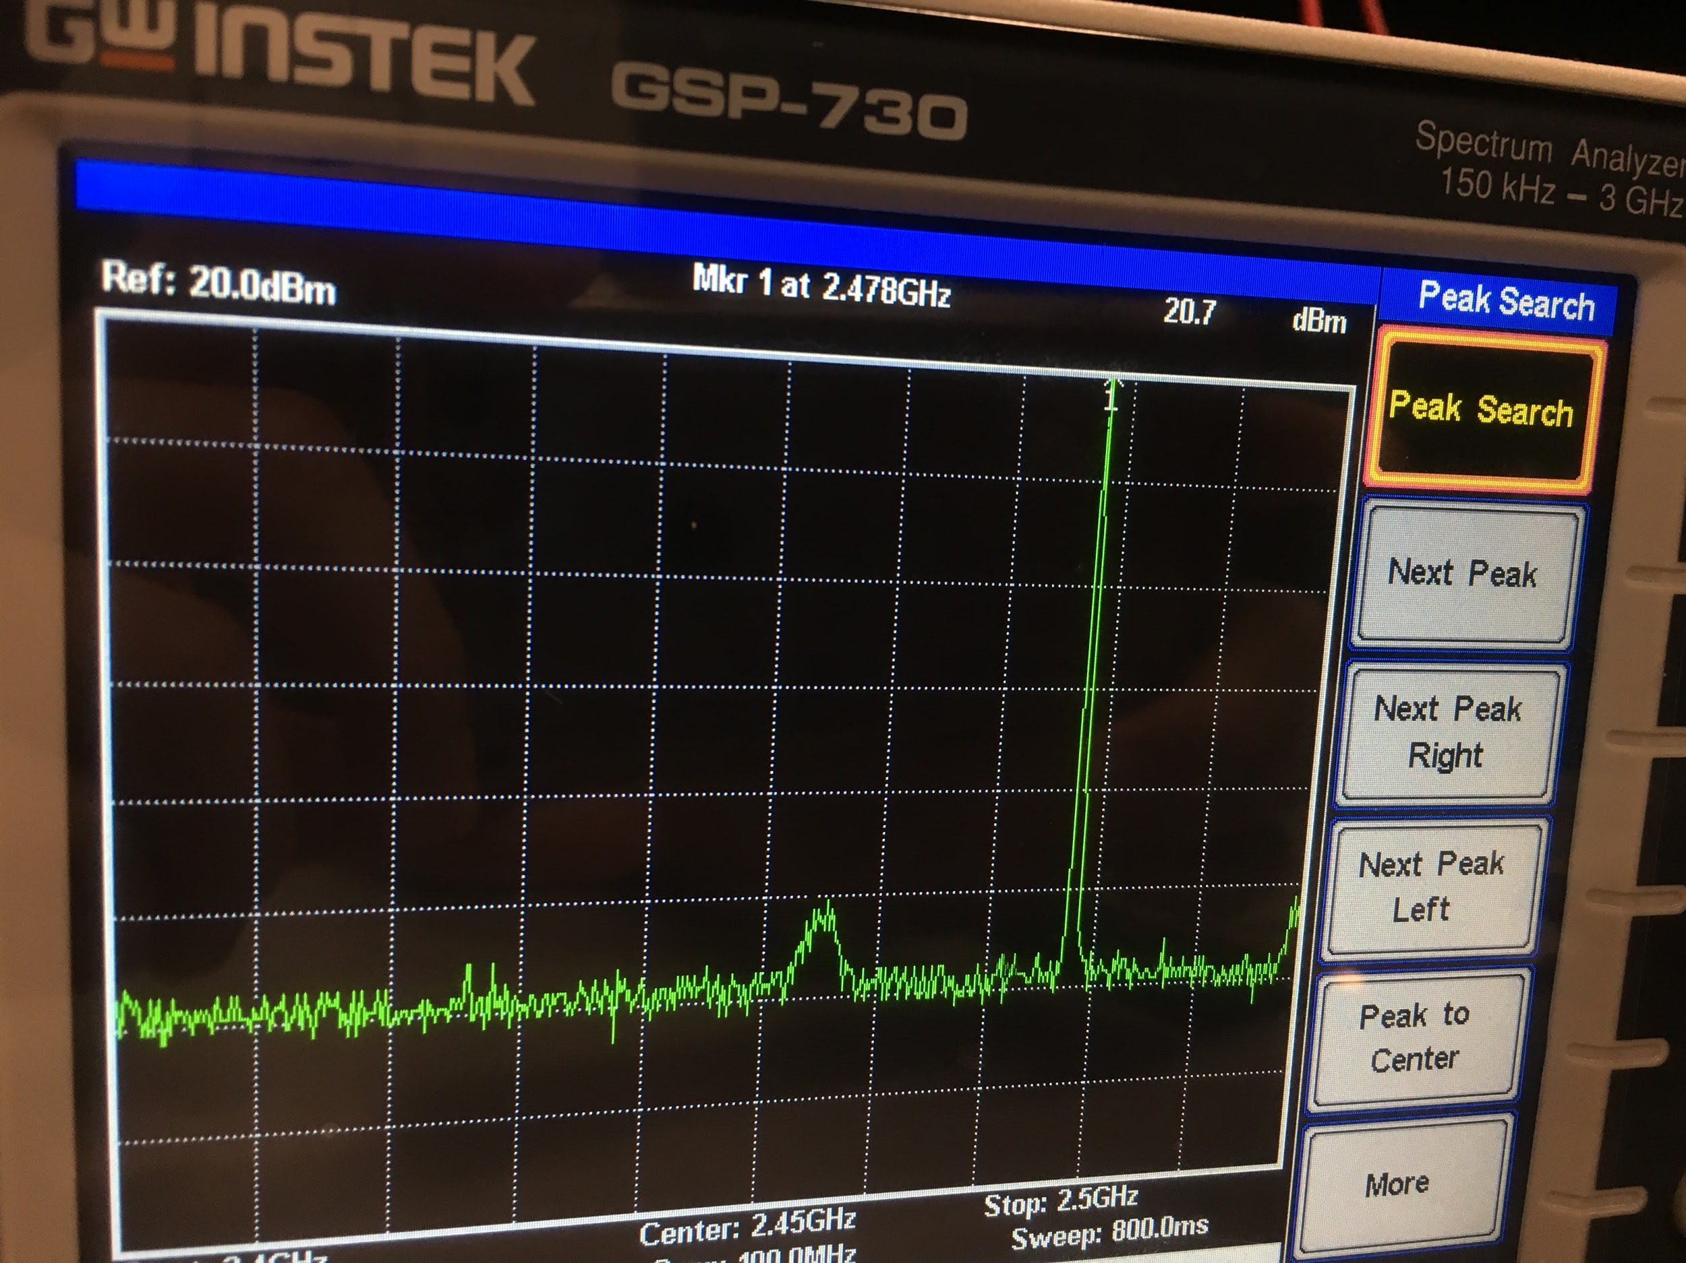

Fig 2: Transmitting end output

We assembled the system and started testing the overall system inside the lab, outside Kemper in the courtyard and in Hutchison Field. We got data and were able to see spikes on our graphs, but had really noisy results. At first, we thought it was our system we went back to debug our boards. The baseband seemed fine we checked different test points and verified that the correct voltage was being outputted at different stages. The RF board was harder to debug we first made sure that the soldered components were not burned out and were making solid contact with the pads. After verifying this we tested again, but still had noisy data. We consulted with Professor Leo and decided to add attenuators to our receiving side. We had a feeling that perhaps we were getting too much gain from our LNA stage and that this was causing our noisy data. We added a 3dB attenuator on the receiving side and ran more test we got a little cleaner figure, but not what we expected. We then used a 10dB attenuator. This made our data less noisy and gave us a better view of where we were standing. With the 10db attenuator we were able to receive data up to 60 meters. After multiple days of testing we were ready to build the platform in which our system will rest on. It wasn’t the nicest looking platform, but it did its job. We had the system rest on a piece of plastic. We used Velcro to keep the receiving antennas (coffee can) in place. We used Styrofoam for the transmitting antenna (Yagi). The system worked perfectly.

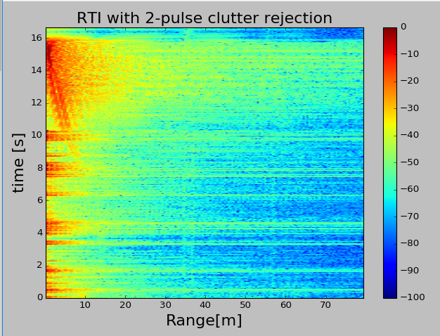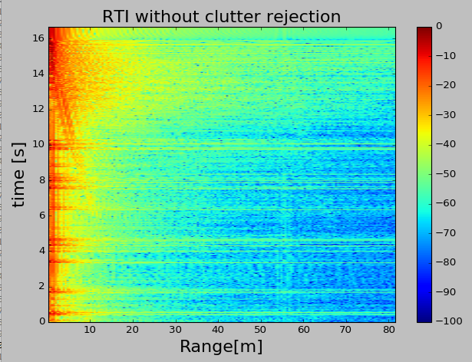

Fig 3: Test Run #1

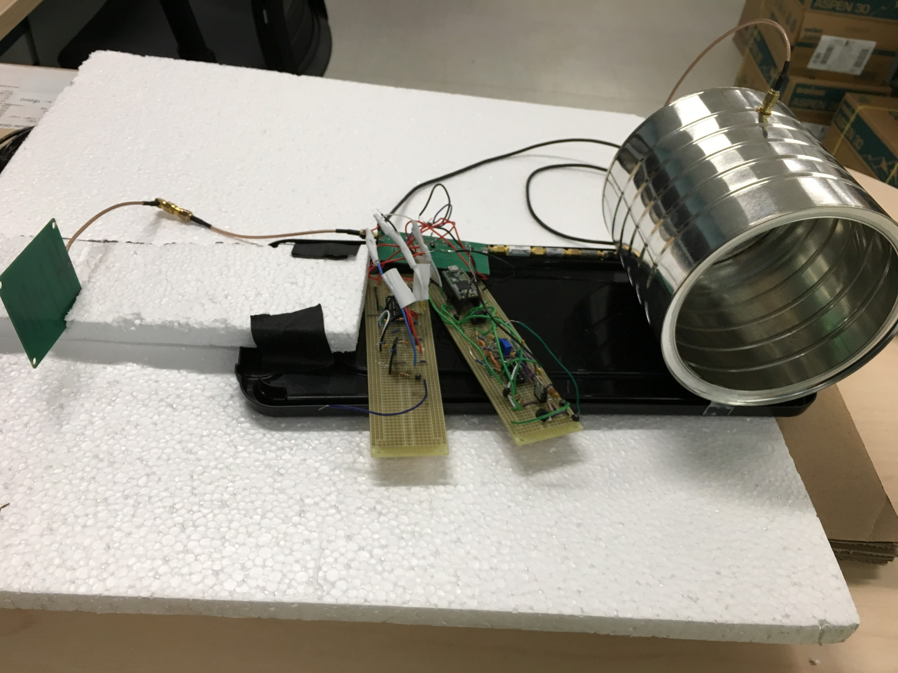

Fig 4: Assembled Radar System

**Competition Results:**

For the competition, we arrived early and ran one more test to make sure everything was working properly. When our turn arrived, the TA’s weighted our system which was 504 grams and recorded our power consumption which was 2.4 W. After they were ready to test our radar. Daniel began taking data while Sonjeii stood at 5 different locations and recorded his location in feet. Once this was done we were given the data and it was up to our team to record the distance we believe our radar was reading at. After looking at the data we reported distances of 40m, 32m, 25m, 20m, and 11m. The correct distance given by Sonjeii was 41m, 35m, 29m, 21m, and 11m and. This concludes that our radar was working perfectly. Our records had one distance be the same as the one provided by the TA while 2 others were of by just 1 meter. The last two were of by 4 meters, but this was due to the fact that our Yagi antennas feel of the platform. We were happy with our results and proved that our radar system was a success and fairly accurate.

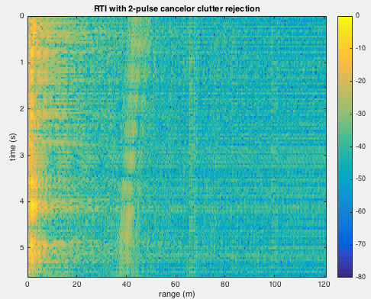

Part 1 of Test: Starting distance was about 50m and person stops around 40m.

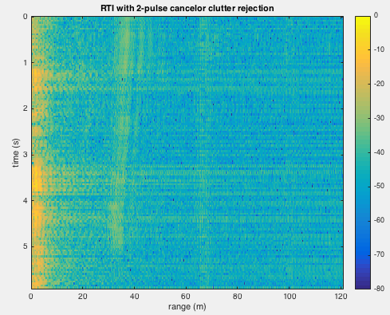

Part 2 of Run: Starting distance is about 40m and ends at about 32m.

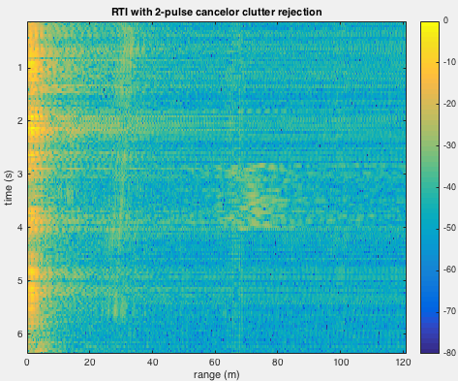

Part 3 of Run: starting distance is about 32m to 25m.

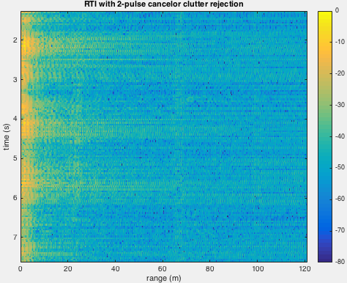

Part 4 of Run: Starting Distance 25m to 20m.

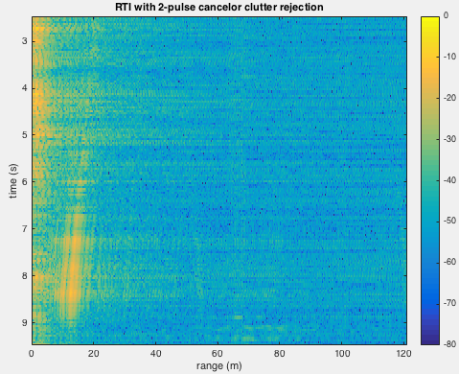

Part 5 of Run: Starting distance 20m and stopping distance is about 10m.

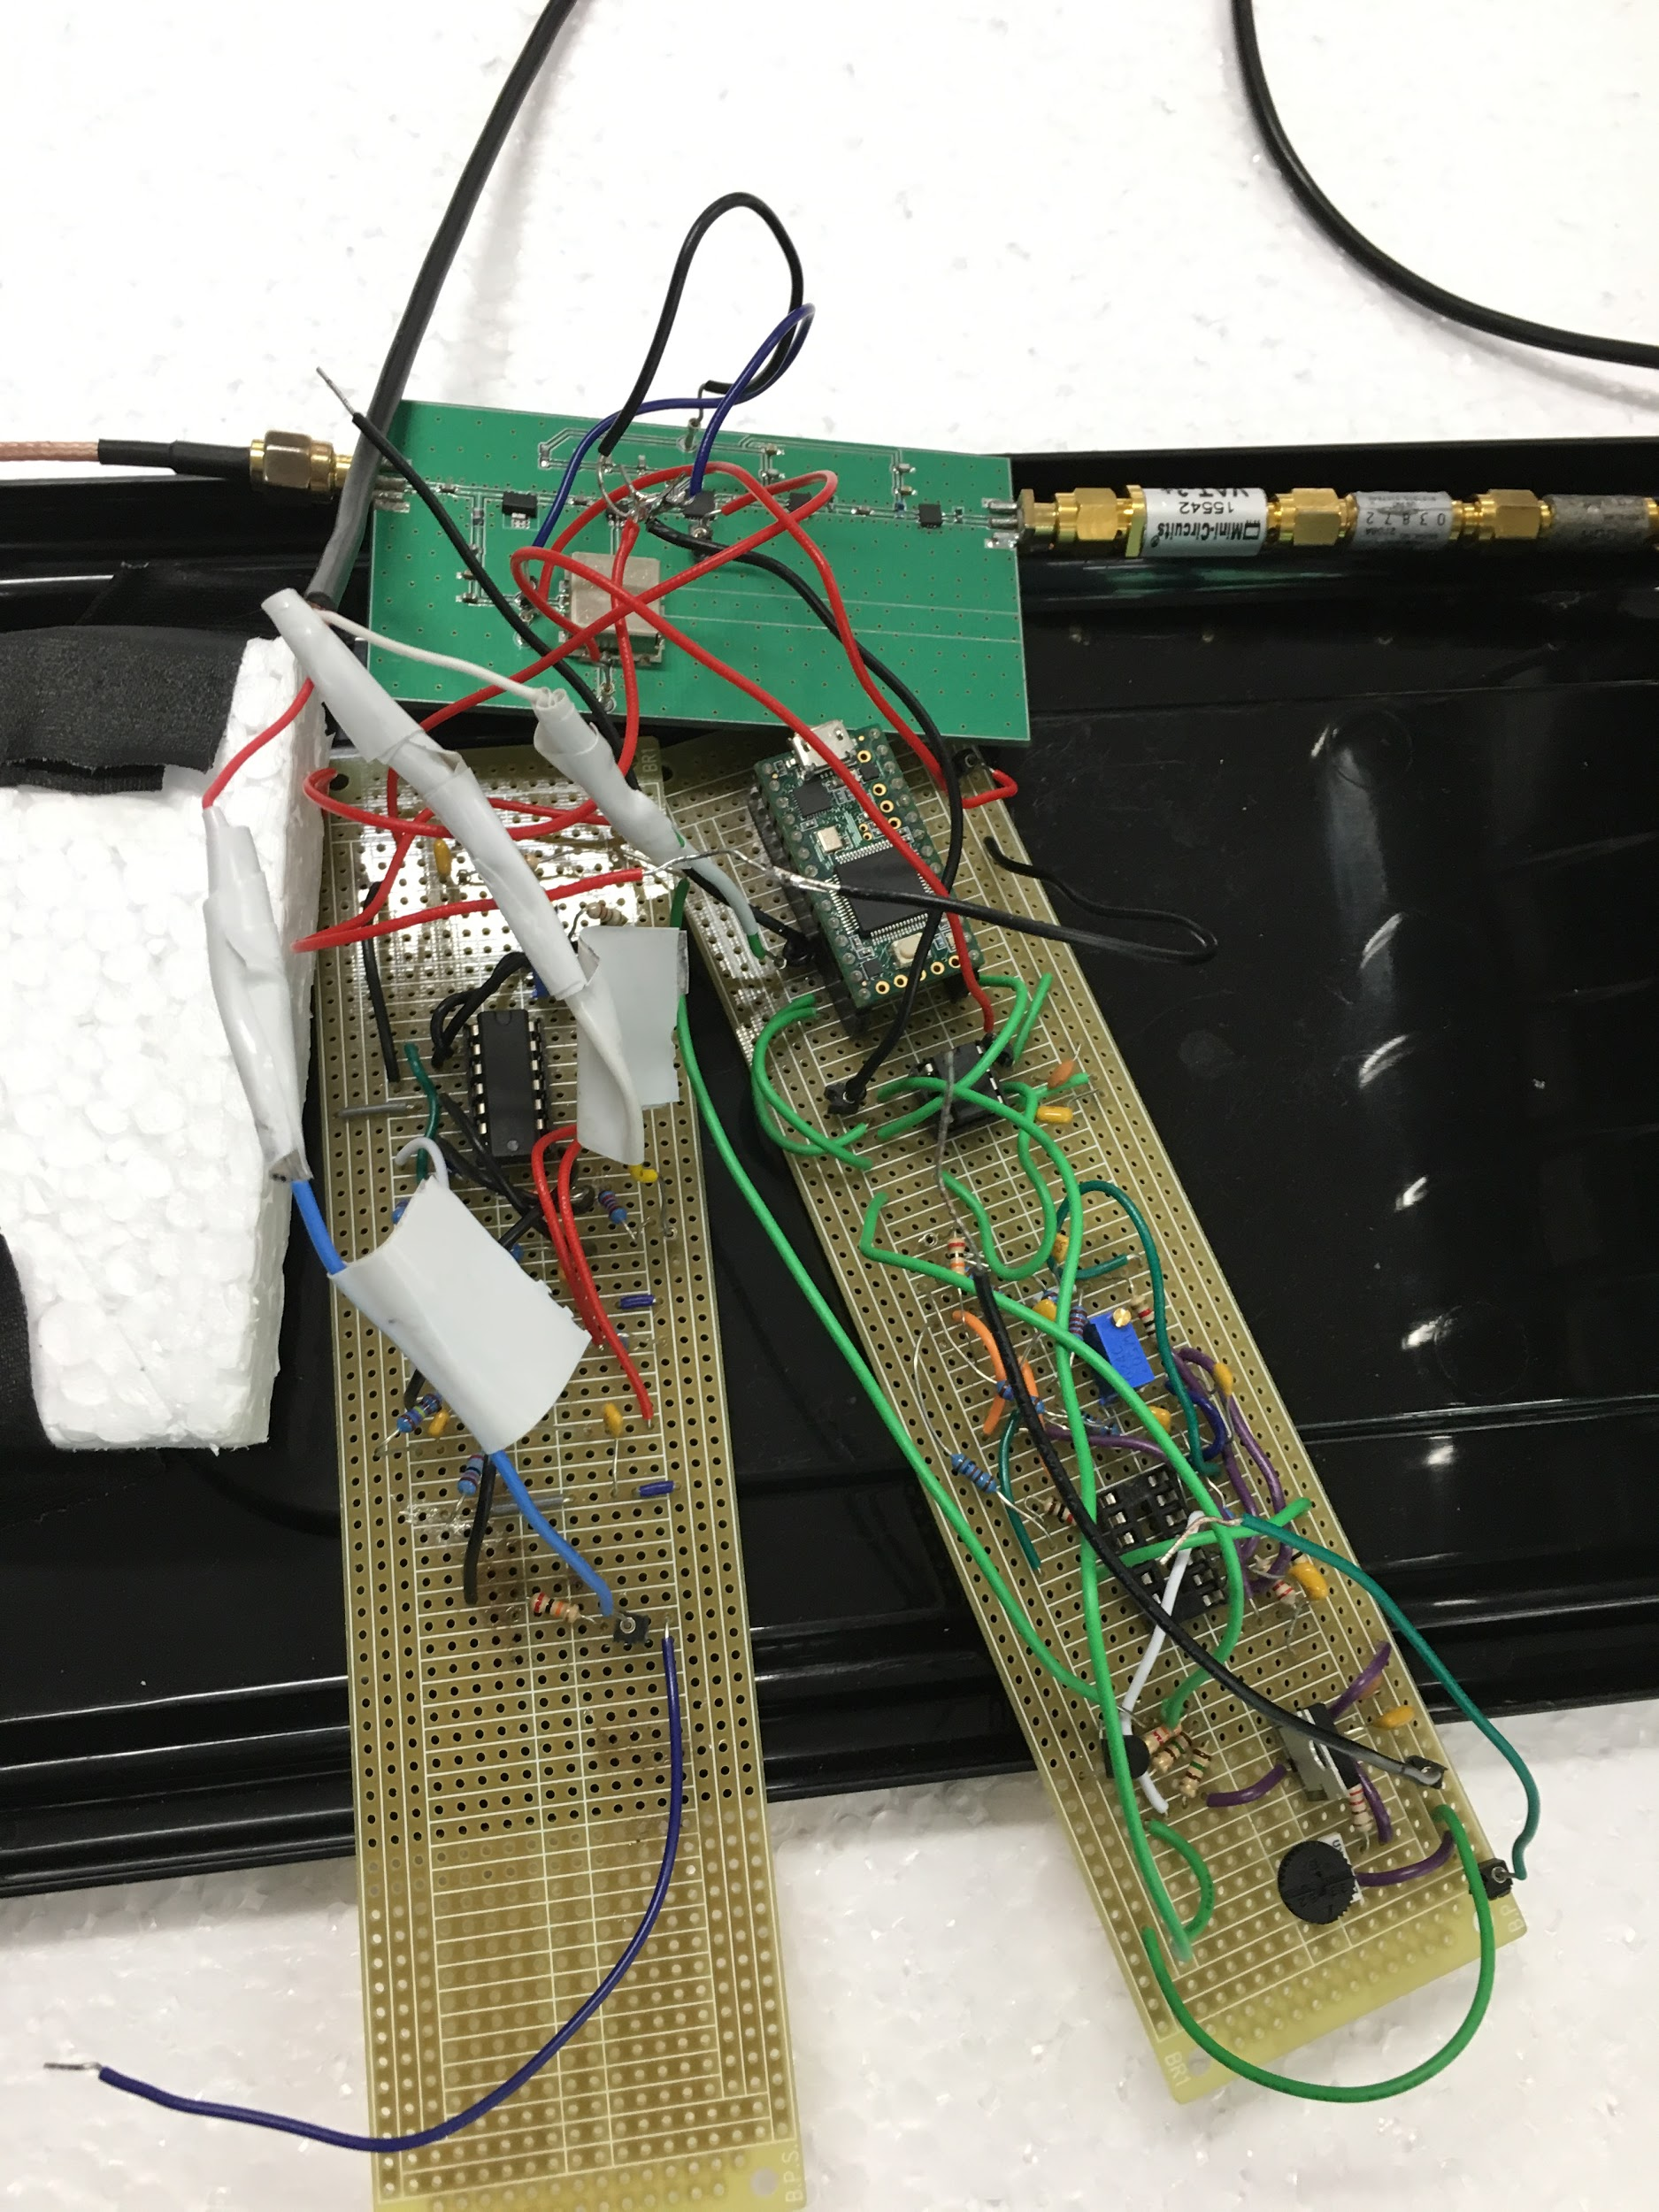

Fig 1: Final PCB and Proto-board of Radar System

**Improvements:**



Figure 1: RF Improvements

Looking back at our system, one way we could've improved the system was eliminating as much noise as possible. In our RF board, we had two low noise amplifiers cascaded. Our team felt that the extra low noise amplifier provided a significant amount of noise to the system. Equally important, the extra low noise amplifier gave us too much gain that it saturated our output signal. This required our team to put some attenuators to our receiving antenna to give a more acceptable output signal. Overall, we felt that we could just removing one LNA could have drastically improved our system.

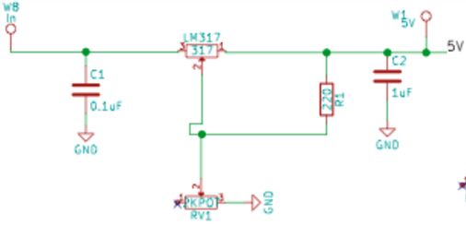

Figure 2: Voltage Regulator Improvement

Other improvements that could been made was the power output and weight. The circuitry that was used to make an 8V to a 5V could've been removed from the system because none of the components for our Quarter 2 design required 8 volts after the overall design. We mainly needed 5 volts and 2.5 volts for our system. Removing the voltage regulator would have decreased the current, thus decreasing our power output. Even the components were the main part of the circuit, it would have reduced some weight as well.

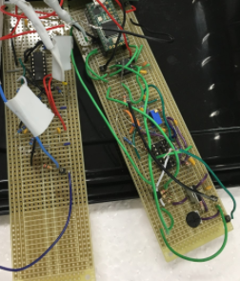

Figure 3. Baseband Board Improvement

Another improvement to our system that could have helped reduce the weight of our system was too successfully implement our baseband PCB board. Looking at the picture above, our baseband was implemented on two separate proto boards. We had to proto boards because we built two different base bands but each proto board was not working properly, leading to use combining the better halves of each board to give use the finished product. If we were to have the base band as one board, it would have eliminated quite a bit of weight and dead components, leading to a better design overall, speaking in terms of weight. Equally important, some of the dead components contributed to our overall power, which could of lead to a more efficient system if this was eliminated.

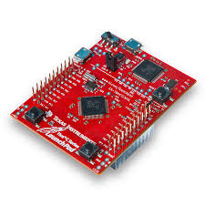

Figure 4: Tiva C Launchpad Microcontroller for DSP

Lastly, implementing the digital signal processing would have greatly improved our system by giving use a real-time analysis. We could have debugged much quicker due to the real-time data as compared to the other method where we had to record then analyze data on a separate software. One of our group members could have implemented this processing method but time and resources were an issue.

**Conclusion:**

In conclusion, our radar was a success. We could meet all the criteria required by the project. Our radar was accurate, as seen in our results. This project helped us all gain skills ranging from time management, teamwork, debugging, and how real world projects work. It’s a great way to transition from student engineers into professionals. Our baseband board didn’t go as planned, but we were able to turn to plan B and go on from there. Although it’s unfortunate that our baseband board didn’t work and added more weight to our system but it gave our team an opportunity to learn. In the real-world things like this happen, just because it doesn’t go according to plan doesn’t mean that it’s a failure. This problem allowed us all to think on the spot and fix the problem, which we successfully accomplished. Debugging is difficult to accomplish on an RF board because it’s difficult to isolate an issue since the components used are high frequency. At the end, we had a working system and as a team could build it within the given timeline. We believe that this course taught us fundamental and higher level RF skills. We were also able to use a CAD program and get practice in fabricating our designs. Overall, we learned how a radar works, how to assemble one and valuable skills that we will each take with us to our future jobs as professional engineers.